**Ideation Phase**

**Brainstorm & Idea Prioritization Template**

| Date | 19 September 2022 |
| --- | --- |
| Team ID | PNT2022TMID50829 |
| Project Name | Real- Time River Water quality monitoring and Control system |
| Maximum Marks | 4 Marks |

**Brainstorm & Idea Prioritization Template:**

The system consists of several sensors which is used to measure physical and chemical parameters of the water. The main components of Wireless Sensor Network (WSN) include a microcontroller for processing the system, communication system for inter and intra node communication and several sensors. Real-time data access can be done by using remote monitoring and Internet of Things (IoT) technology.

**Datep-1: Team Gathering, Collaboration and Select the Problem Statement**

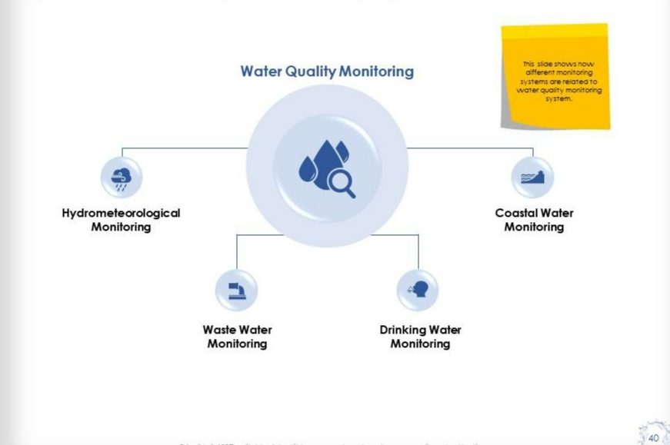

**Step-2: Brainstorm, Idea Listing and Grouping**

* 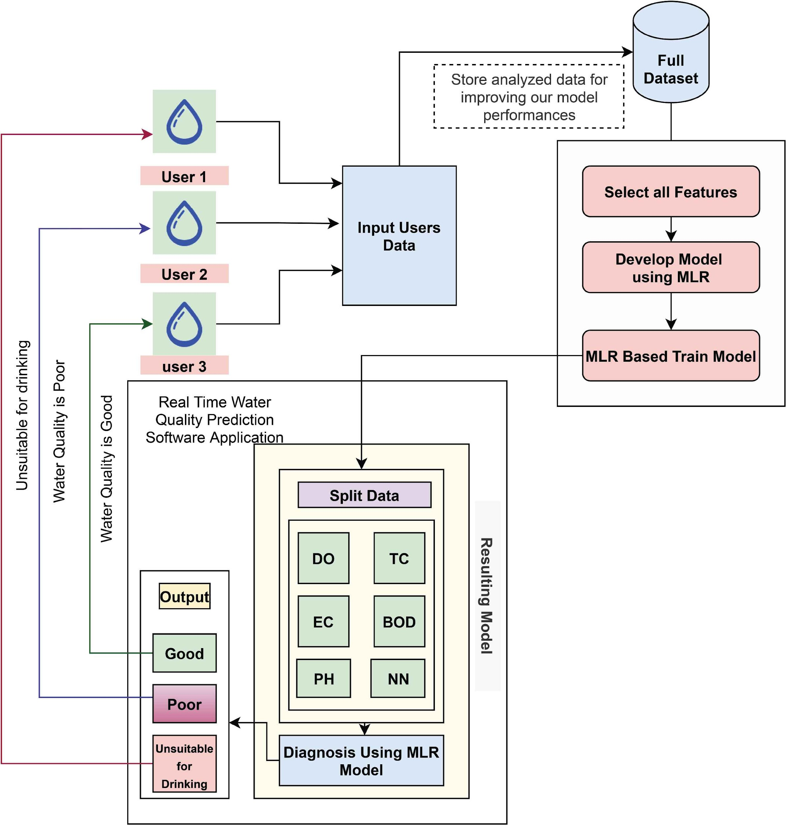

**Step-3: Idea Prioritization**

